**1**.Write a program to reverse a word using loop? (Not to use inbuilt functions)

**Code :-**

public class Reverse

{

public static void main(String[] args) {

String string = "saveetha";

String reversedStr = "";

for(int i = string.length()-1; i >= 0; i--){

reversedStr = reversedStr + string.charAt(i);

}

System.out.println("Original string: " + string);

System.out.println("Reverse of given string: " + reversedStr);

}

}

**Out Put :-**

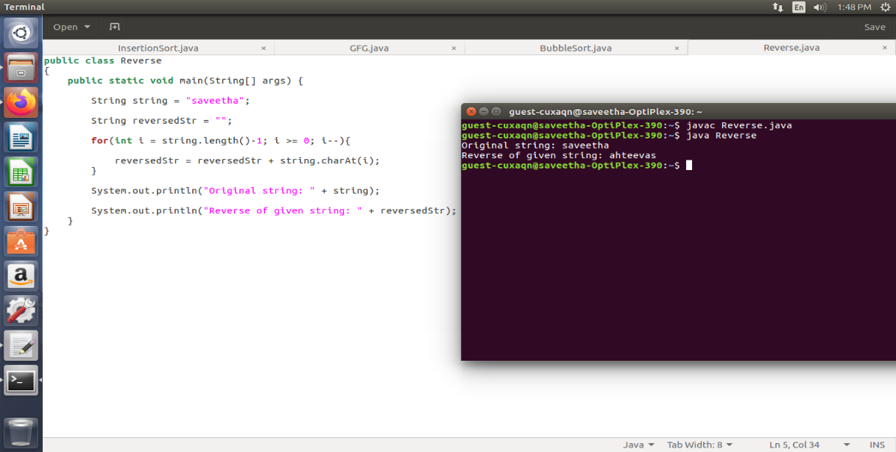

**2.** Write a program to check the entered user name is valid or not. Get both the inputs from the user.

**Code :-**

import java.util.regex.*;

class ValidUserName {

public static boolean isValidUsername(String name)

{

String regex = "^[A-Za-z]\\w{5,29}$";

Pattern p = Pattern.compile(regex);

if (name == null) {

return false;

}

Matcher m = p.matcher(name);

return m.matches();

}

public static void main(String[] args)

{

String str1 = "Geeksforgeeks";

System.out.println(isValidUsername(str1));

String str3 = "1Geeksforgeeks";

System.out.println(isValidUsername(str3));

String str5 = "Ge";

System.out.println(isValidUsername(str5));

}

}

**OutPut:-**

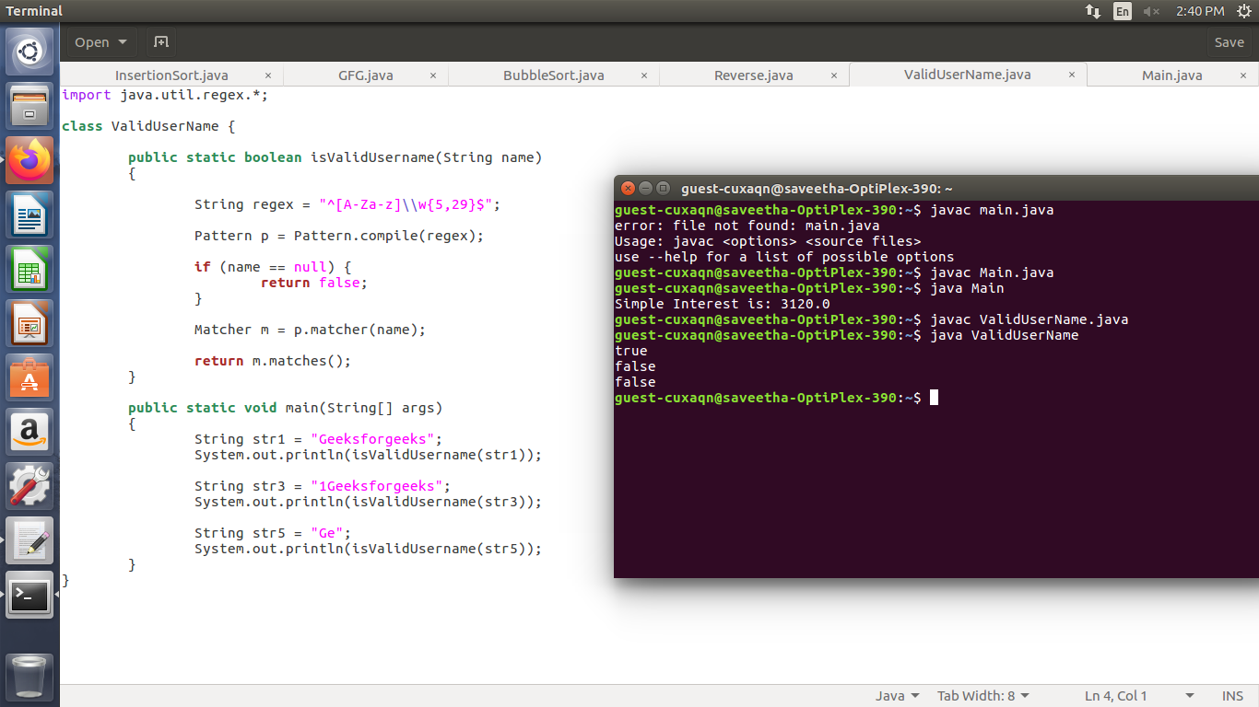

**3.** Write a program to reverse a number using loop?(Get the input from user)

**Code :-**

public class ReverseNumber

{

public static void main(String[] args)

{

int number = 987654, reverse = 0;

while(number != 0)

{

int remainder = number % 10;

reverse = reverse * 10 + remainder;

number = number/10;

}

System.out.println("The reverse of the given number is: " + reverse);

}

}

**OutPut :-**

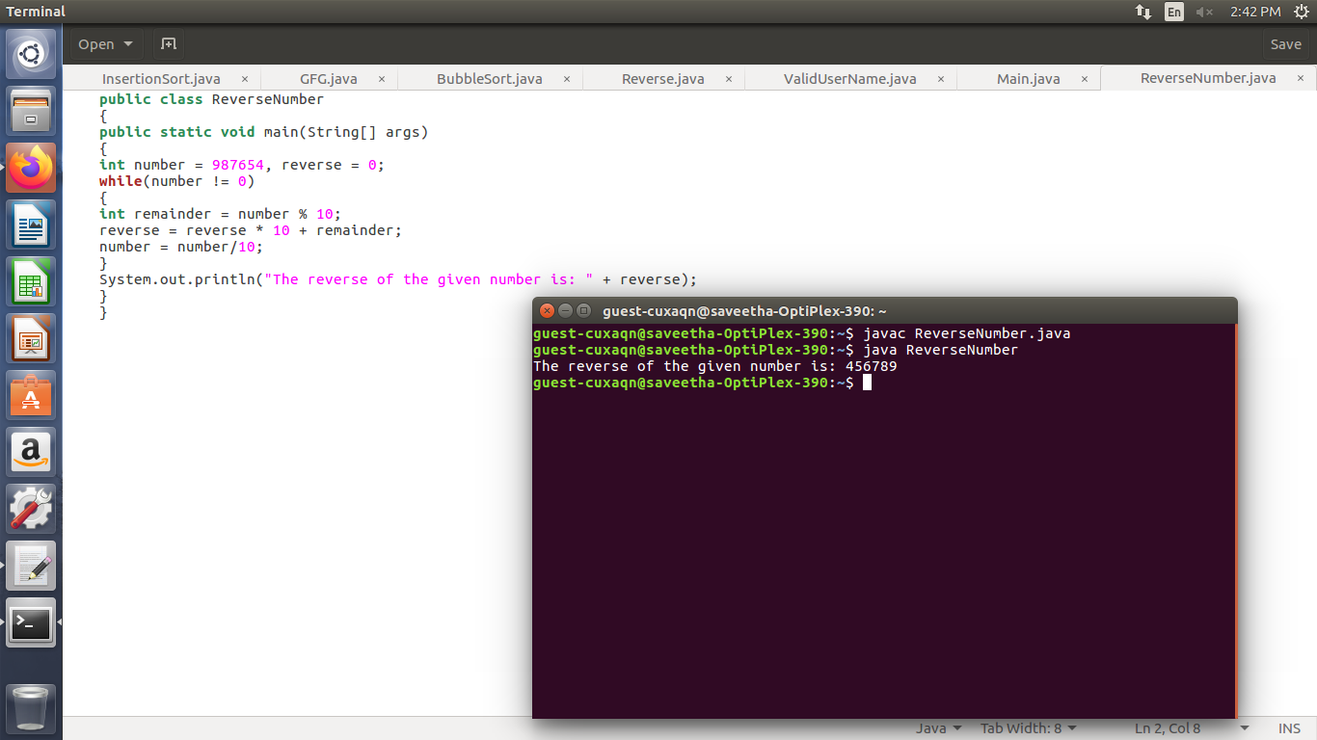

**4.** Write a program to find whether the person is eligible for vote or not. And if that particular person is not eligible, then print how many years are left to be eligible.

**Code :-**

import java.util.Scanner;

public class Voting

{

public static void main(String[] args)

{

Scanner input = new Scanner(System.in);

int age = 0;

System.out.printf("Enter the Age : ");

age = input.nextInt();

int res = age >= 18?1:0;

switch (res)

{

case 0:

System.out.printf("You are Not Eligible for Voting...");

break;

case 1:

System.out.printf("You are Eligible for Voting...");

break;

}

}

}

**OutPut :-**

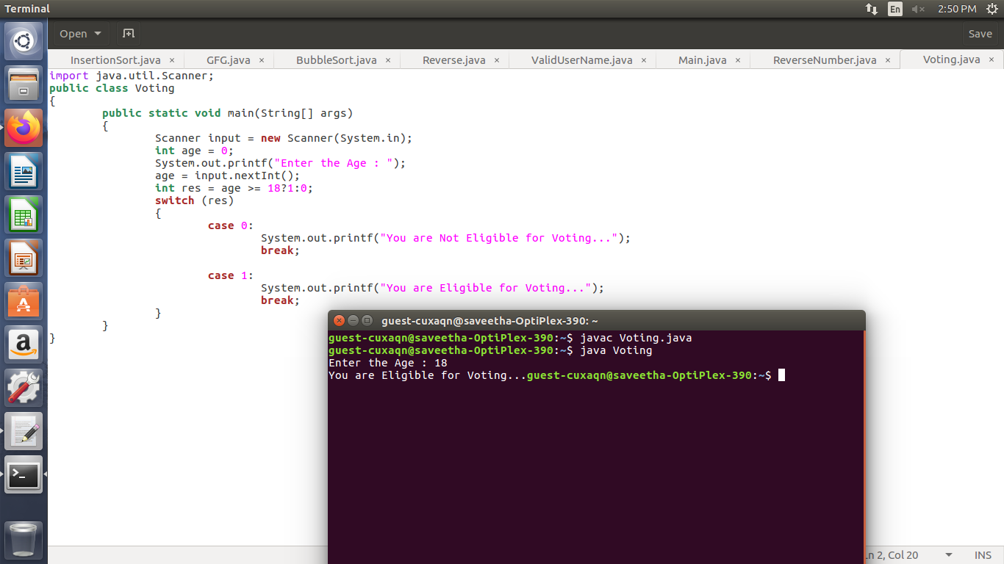

**5.** Find the LCM and GCD of n numbers?

**Code :-**

import java.io.*;

class LCM {

static int gcd(int a, int b) {

if (b == 0)

return a;

else

return gcd(b, a % b);

}

static int lcm(int a, int b, int gcdValue)

{

return Math.abs(a * b) / gcdValue;

}

public static void main(String[] args) {

int a = 20, b = 30, gcdValue;

gcdValue = gcd(a, b);

System.out.println("GCD = " + gcdValue);

System.out.println("LCM = " + lcm(a, b, gcdValue));

}

}

OutPut :-

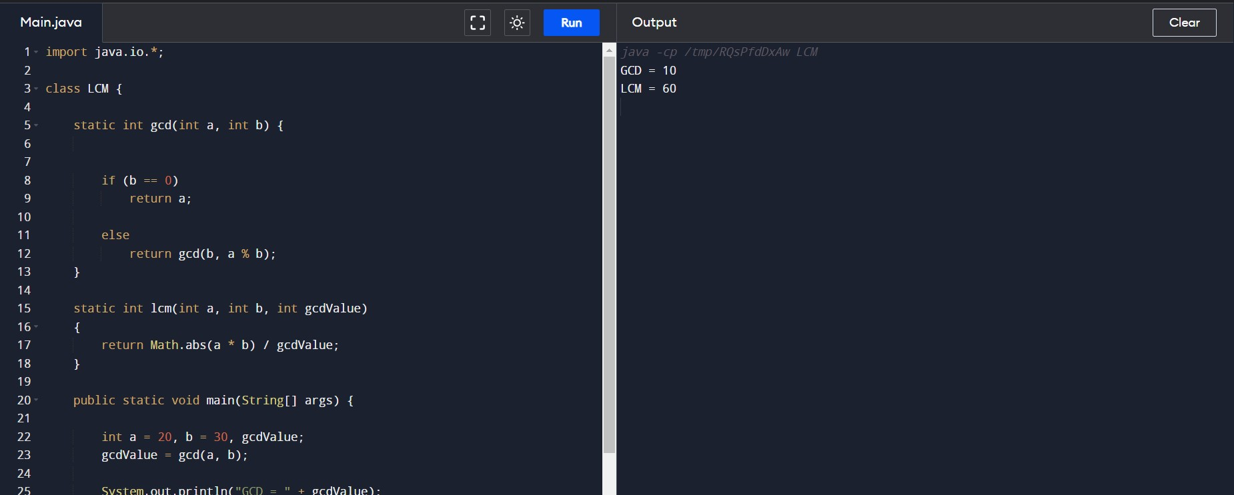

6. Write a program to print Right Triangle Star Pattern

Code :-

import java.io.*;

// Java code to demonstrate right star triangle

public class GeeksForGeeks {

// Function to demonstrate printing pattern

public static void StarRightTriangle(int n)

{

int a, b;

// outer loop to handle number of rows

// k in this case

for (a = 0; a < n; a++) {

// inner loop to handle number of columns

// values changing acc. to outer loop

for (b = 0; b <= a; b++) {

// printing stars

System.out.print("* ");

}

// end-line

System.out.println();

}

}

// Driver Function

public static void main(String args[])

{

int k = 5;

StarRightTriangle(k);

}

}

OutPut :-

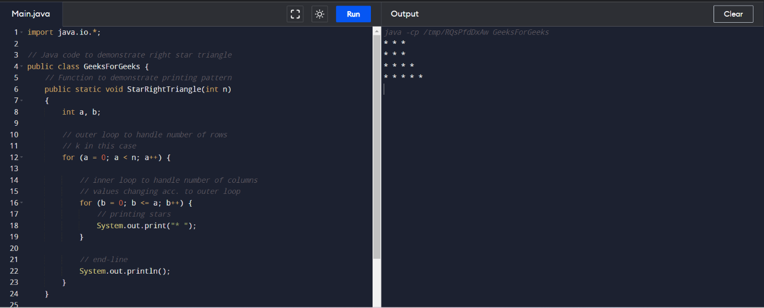

# 7. Java Program to Print Pascal’s Triangle

Code :-

// Print Pascal's Triangle in Java

import java.io.*;

class GFG {

public int factorial(int i)

{

if (i == 0)

return 1;

return i * factorial(i - 1);

}

public static void main(String[] args)

{

int n = 4, i, j;

GFG g = new GFG();

for (i = 0; i <= n; i++) {

for (j = 0; j <= n - i; j++) {

// for left spacing

System.out.print(" ");

}

for (j = 0; j <= i; j++) {

// nCr formula

System.out.print(

" "

+ g.factorial(i)

/ (g.factorial(i - j)

* g.factorial(j)));

}

// for newline

System.out.println();

}

}

}

OutPut :-

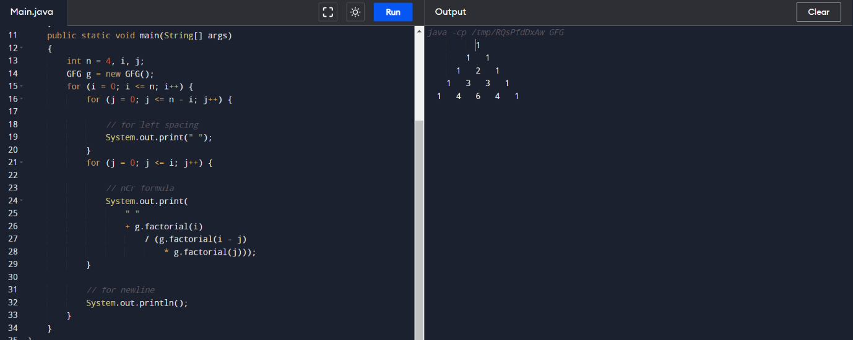

8. Write a program using function to calculate the simple interest. Suppose the customer is a senior citizen. He is being offered 12 percent rate of interest; for all other customers, the ROI is 10 percent

// Java program to compute

// simple interest for given principal

// amount, time and rate of interest.

import java.io.*;

class GFG {

public static void main(String args[])

{

// We can change values here for

// different inputs

float P = 1, R = 1, T = 1;

/* Calculate simple interest */

float SI = (P * T * R) / 100;

System.out.println("Simple interest = " + SI);

}

}

OutPut :-

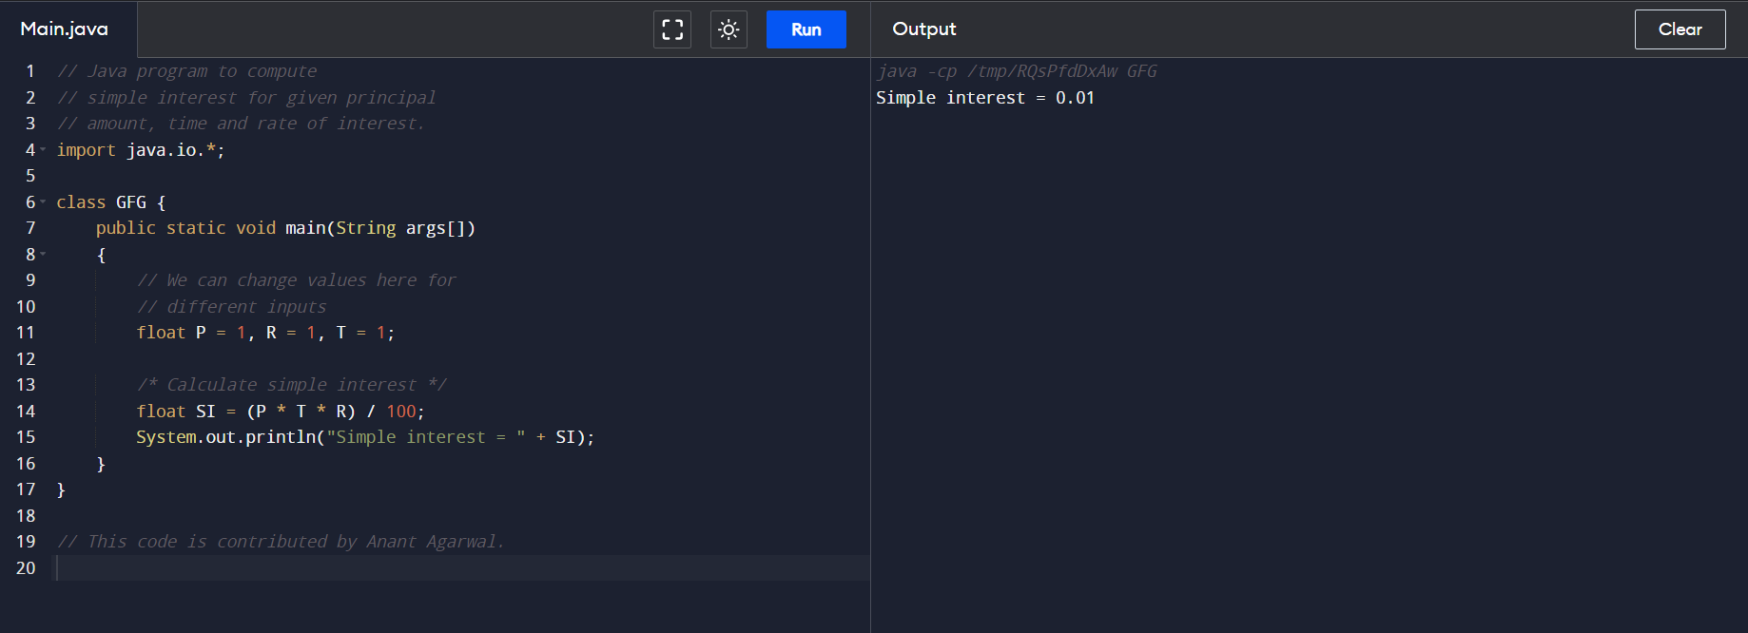

9. Write a Java Program to Find Even Sum of Fibonacci Series Till number N?

Code :-

// Java Program to find even sum of

// fibonacci Series Till number N

import java.io.*;

class geeksforgeeks {

// Computing the value of first fibonacci series

// and storing the sum of even indexed numbers

static int Fib_Even_Sum(int N)

{

if (N <= 0)

return 0;

int fib[] = new int[2 * N + 1];

fib[0] = 0;

fib[1] = 1;

// Initializing the sum

int s = 0;

// Adding remaining numbers

for (int j = 2; j <= 2 * N; j++) {

fib[j] = fib[j - 1] + fib[j - 2];

// Only considering even indexes

if (j % 2 == 0)

s += fib[j];

}

return s;

}

// The Driver code

public static void main(String[] args)

{

int N = 11;

// Prints the sum of even-indexed numbers

System.out.println(

"Even sum of fibonacci series till number " + N

+ " is: " + +Fib_Even_Sum(N));

}

}

Out Put :-

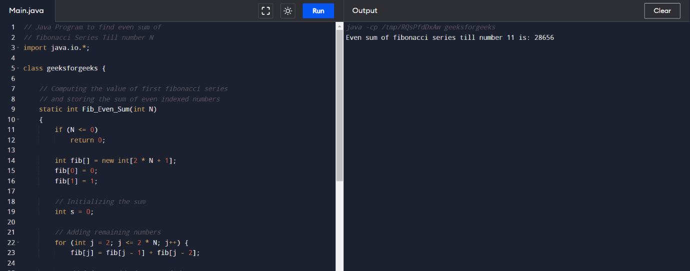

1. Write a program for matrix addition?

Code :-

**public** **class** MatrixAdditionExample{

**public** **static** **void** main(String args[]){

//creating two matrices

**int** a[][]={{1,3,4},{2,4,3},{3,4,5}};

**int** b[][]={{1,3,4},{2,4,3},{1,2,4}};

//creating another matrix to store the sum of two matrices

**int** c[][]=**new** **int**[3][3];  //3 rows and 3 columns

//adding and printing addition of 2 matrices

**for**(**int** i=0;i<3;i++){

**for**(**int** j=0;j<3;j++){

c[i][j]=a[i][j]+b[i][j];    //use - for subtraction

System.out.print(c[i][j]+" ");

}

System.out.println();//new line

}

}}

Out Put :-

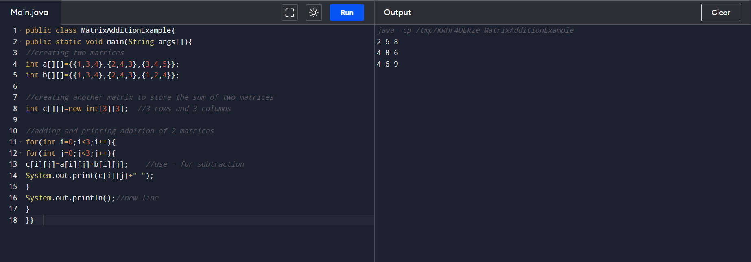

1. Write a program to print rectangle symbol pattern.

Get the symbol as input from user.

Code :-

import java.util.Scanner;

public class RectangleStar2 {

private static Scanner sc;

public static void main(String[] args)

{

int rows, columns, i = 1, j;

sc = new Scanner(System.in);

System.out.print(" Please Enter Number of Rows : ");

rows = sc.nextInt();

System.out.print(" Please Enter Number of Columns : ");

columns = sc.nextInt();

while(i <= rows)

{

j = 1;

while(j <= columns)

{

System.out.print("*");

j++;

}

i++;

System.out.print("\n");

}

}

}

OutPut :-

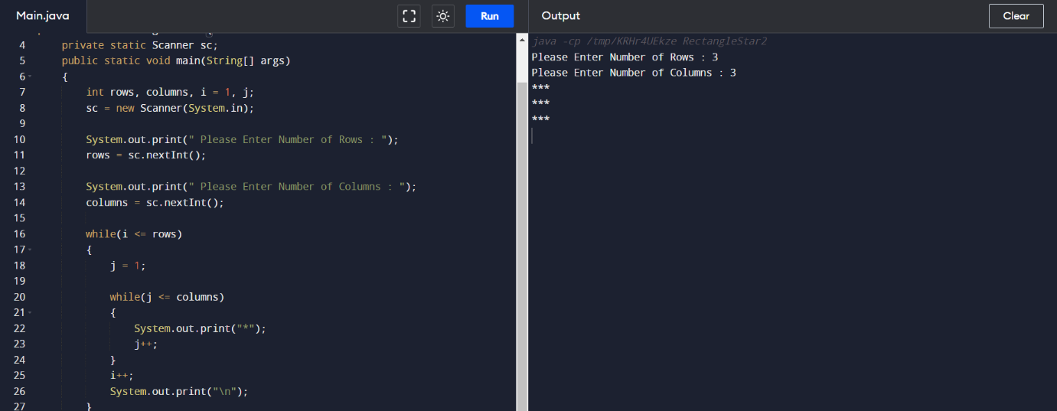

13. Write a program that would sort a list of names in alphabetical order Ascending or Descending, choice get from the user?

Code :-

// Java Program to Sort Names in an Alphabetical Order

import java.io.*;

class GFG {

public static void main(String[] args)

{

// storing input in variable

int n = 4;

// create string array called names

String names[]

= { "Rahul", "Ajay", "Gourav", "Riya" };

String temp;

for (int i = 0; i < n; i++) {

for (int j = i + 1; j < n; j++) {

// to compare one string with other strings

if (names[i].compareTo(names[j]) > 0) {

// swapping

temp = names[i];

names[i] = names[j];

names[j] = temp;

}

}

}

// print output array

System.out.println(

"The names in alphabetical order are: ");

for (int i = 0; i < n; i++) {

System.out.println(names[i]);

}

}

}

OutPut :-

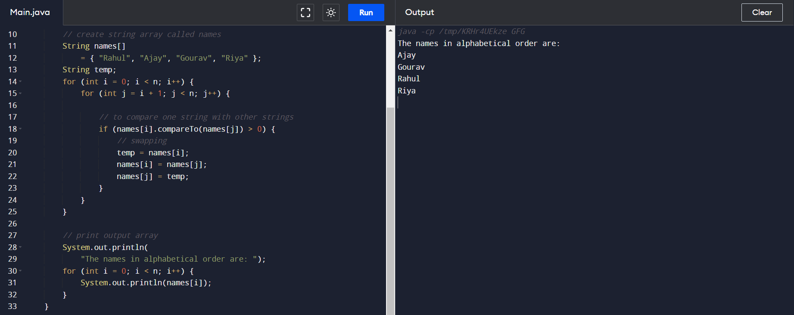

14. write a program for matrix multiplication in java

Codes :-

**public** **class** MatrixMultiplicationExample{

**public** **static** **void** main(String args[]){

//creating two matrices

**int** a[][]={{1,1,1},{2,2,2},{3,3,3}};

**int** b[][]={{1,1,1},{2,2,2},{3,3,3}};

//creating another matrix to store the multiplication of two matrices

**int** c[][]=**new** **int**[3][3];  //3 rows and 3 columns

//multiplying and printing multiplication of 2 matrices

**for**(**int** i=0;i<3;i++){

**for**(**int** j=0;j<3;j++){

c[i][j]=0;

**for**(**int** k=0;k<3;k++)

{

c[i][j]+=a[i][k]*b[k][j];

}//end of k loop

System.out.print(c[i][j]+" ");  //printing matrix element

}//end of j loop

System.out.println();//new line

}

}}

OutPut :-

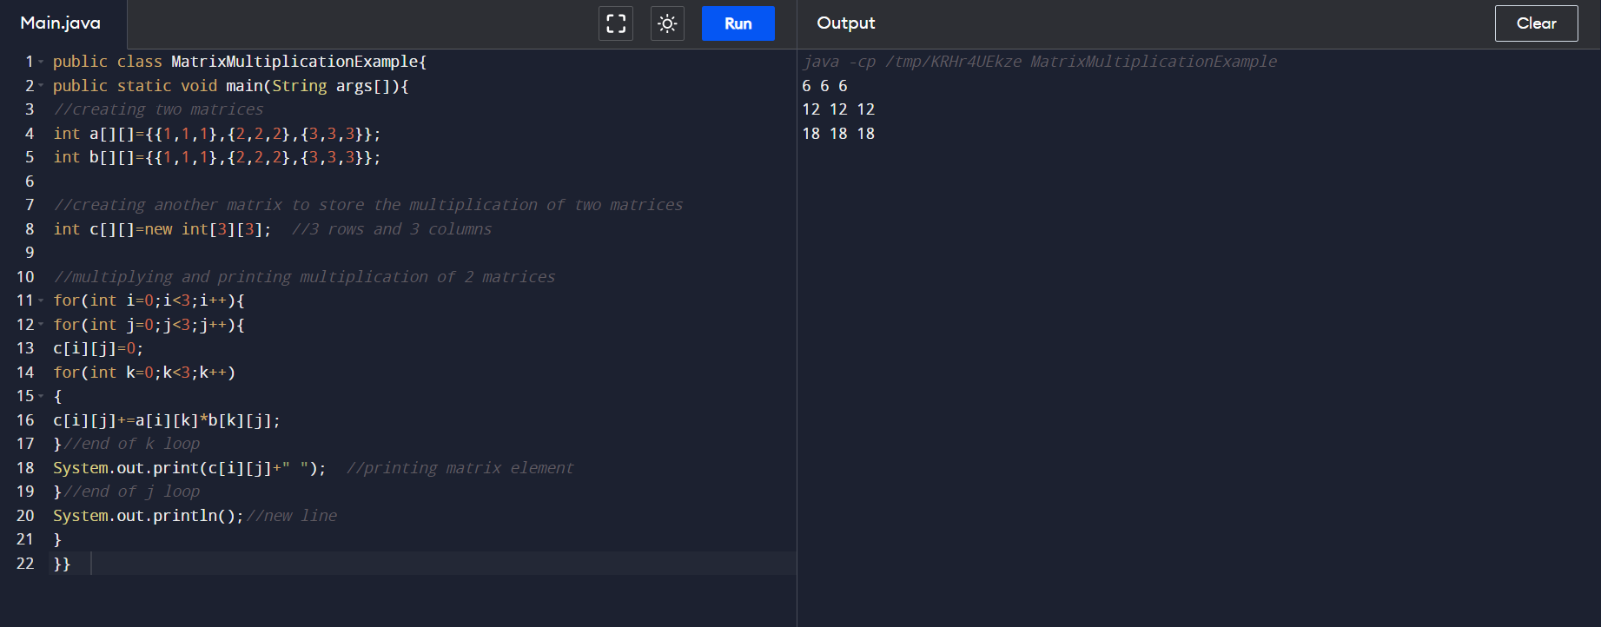

15. Write a program to print the following pattern

Code :-

// Java Program to print pattern

// Square hollow pattern

import java.util.*;

public class GeeksForGeeks {

// Function to demonstrate pattern

public static void printPattern(int n)

{

int i, j;

// outer loop to handle number of rows

for (i = 0; i < n; i++) {

// inner loop to handle number of columns

for (j = 0; j < n; j++) {

// star will print only when it is in first

// row or last row or first column or last

// column

if (i == 0 || j == 0 || i == n - 1

|| j == n - 1) {

System.out.print("*");

}

// otherwise print space only.

else {

System.out.print(" ");

}

}

System.out.println();

}

}

// Driver Function

public static void main(String args[])

{

int n = 6;

printPattern(n);

}

}

OutPut :-

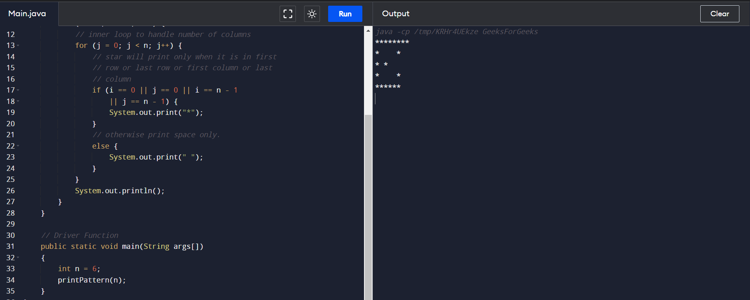

16. Write a program to print the special characters separately and print number of Special characters in the line?

Code:-

// Java Program to Check Whether String contains Special

// Characters Using Character Class

// Importing input output classes

import java.io.*;

// Main class

class GFG {

// Method 1

// Main driver method

public static void main(String[] args)

{

// Declaring and initializing count for

// special characters

int count = 0;

// Input custom string

String s

= "!#$GeeeksforGeeks.Computer.Science.Portal!!";

// Iterating through the string

// using standard length() method

for (int i = 0; i < s.length(); i++) {

// Checking the character for not being a

// letter,digit or space

if (!Character.isDigit(s.charAt(i))

&& !Character.isLetter(s.charAt(i))

&& !Character.isWhitespace(s.charAt(i))) {

// Incrementing the countr for spl

// characters by unity

count++;

}

}

// When there is no special character encountered

if (count == 0)

// Display the print statement

System.out.println(

"No Special Characters found.");

else

// Special character/s found then

// Display the print statement

System.out.println(

"String has Special Characters\n" + count + " "

+ "Special Characters found.");

}

}

Output:-

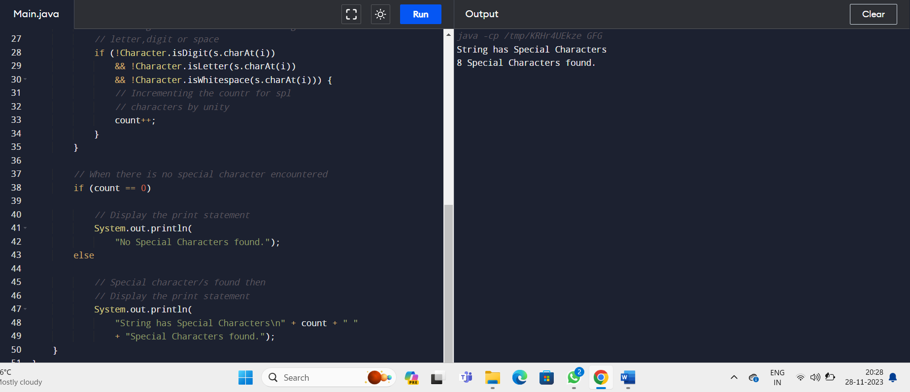

17. Write a program to print all the composite numbers between a and b?

Code :-

import java.util.Scanner;

class finding

{

int flag,n;

finding()

{

System.out.print("Enter range to find the composite numbers:");

Scanner in=new Scanner(System.in);

n=in.nextInt();

for(int i=2;i<=n;i++)

{

flag=0;

for(int j=2;j<i;j++)

{

if(i%j ==0)

flag++;

}

if(flag!=0)

System.out.println("one of the composite number is:" + i);

}

}

}

class composite

{

public static void main(String a[])

{

finding ob=new finding();

}

}

OutPut:-

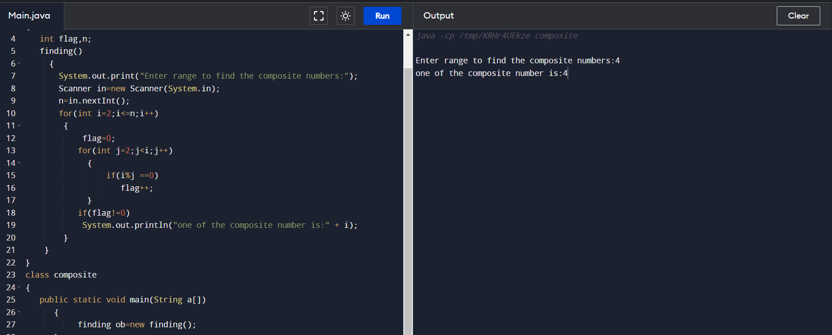

18. Write a program to print the Inverted Full Pyramid pattern?

Code :-

// Java program to Print Reverse Pyramid Star Pattern

// Using While loop

// Importing input output classes

import java.io.*;

// Main class

class GFG {

// Main driver method

public static void main(String[] args)

{

// Declaring and initializing variable to

// Size of the pyramid

int number = 7;

int i = number, j;

// Nested while loops

// Outer loop

// Till condition holds true

while (i > 0) {

j = 0;

// Inner loop

// Condition check

while (j++ < number - i) {

// Print whitespaces

System.out.print(" ");

}

j = 0;

// Inner loop

// Condition check

while (j++ < (i * 2) - 1) {

// Print star

System.out.print("*");

}

// By now, we reach end of execution for one row

// so next line

System.out.println();

i--;

}

}

}

OutPut:-

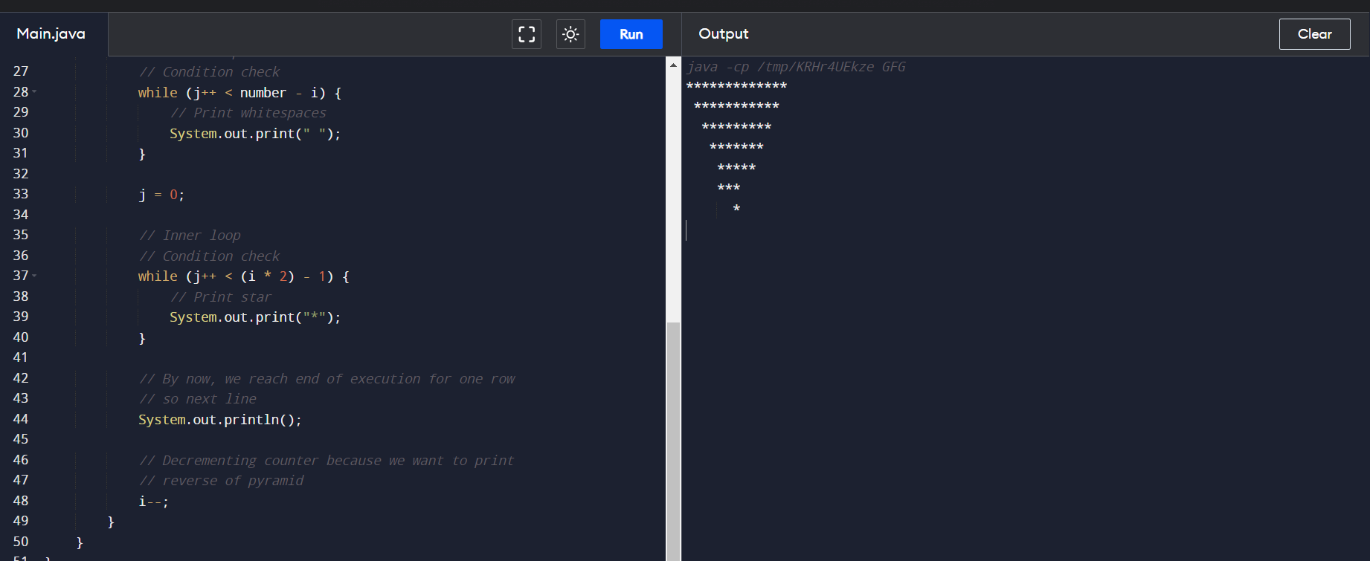

1. Find the Mean, Median, Mode of the array of numbers?

Code :-

// C program to find mean and median of

// an array

#include <stdio.h>

#include <stdlib.h>

// Function to compare two integers for qsort

int cmpfunc(const void* a, const void* b)

{

return (*(int*)a - *(int*)b);

}

// Function for calculating mean

double findMean(int a[], int n)

{

int sum = 0;

for (int i = 0; i < n; i++)

sum += a[i];

return (double)sum / (double)n;

}

double findMedian(int a[], int n)

{

// First we sort the array

qsort(a, n, sizeof(int), cmpfunc);

if (n % 2 != 0)

return (double)a[n / 2];

return (double)(a[(n - 1) / 2] + a[n / 2]) / 2.0;

}

int main()

{

int a[] = { 1, 3, 4, 2, 7, 5, 8, 6 };

int N = sizeof(a) / sizeof(a[0]);

// Function call

printf("Mean = %f\n", findMean(a, N));

printf("Median = %f\n", findMedian(a, N));

return 0;

}

Output:-

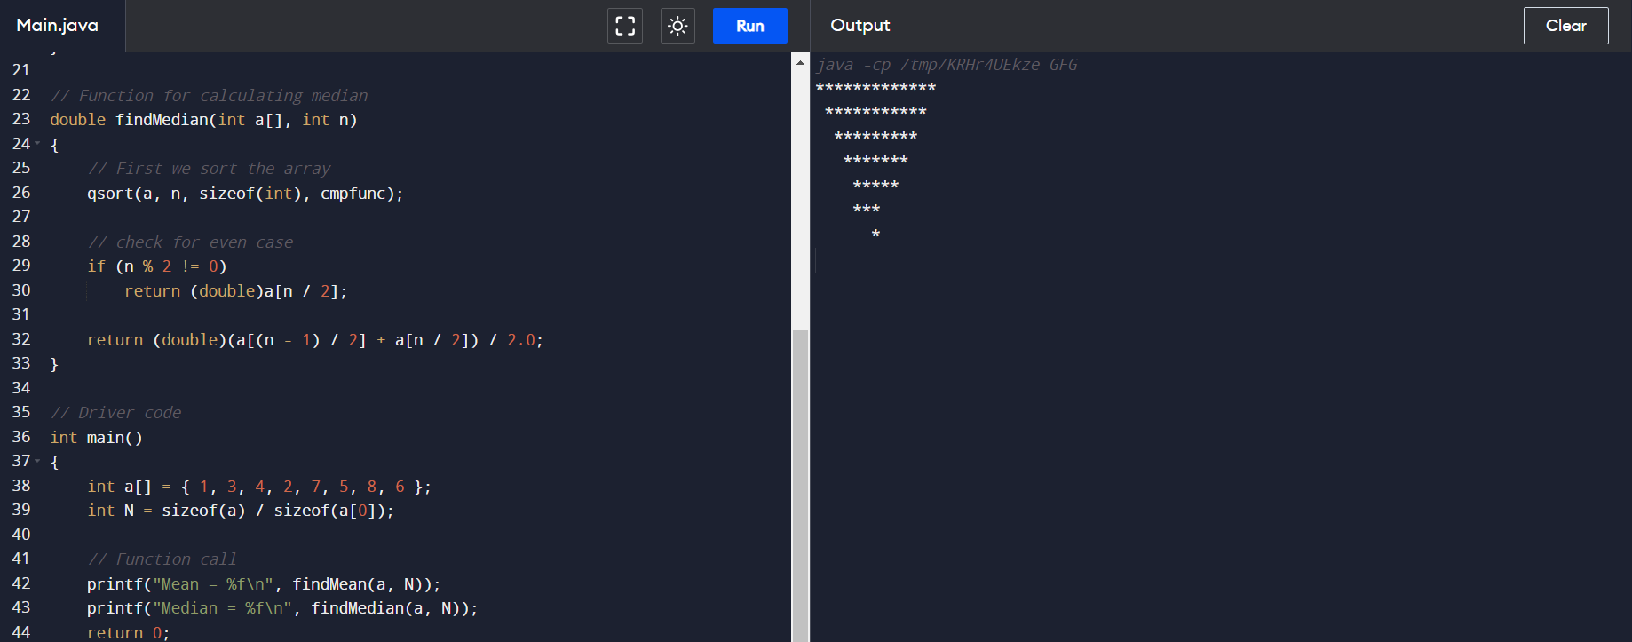

1. Find the factorial of N ?

Code :-

**class** FactorialExample{

**public** **static** **void** main(String args[]){

**int** i,fact=1;

**int** number=5;//It is the number to calculate factorial

**for**(i=1;i<=number;i++){

      fact=fact*i;

  }

  System.out.println("Factorial of "+number+" is: "+fact);

 }

}

OutPut :-

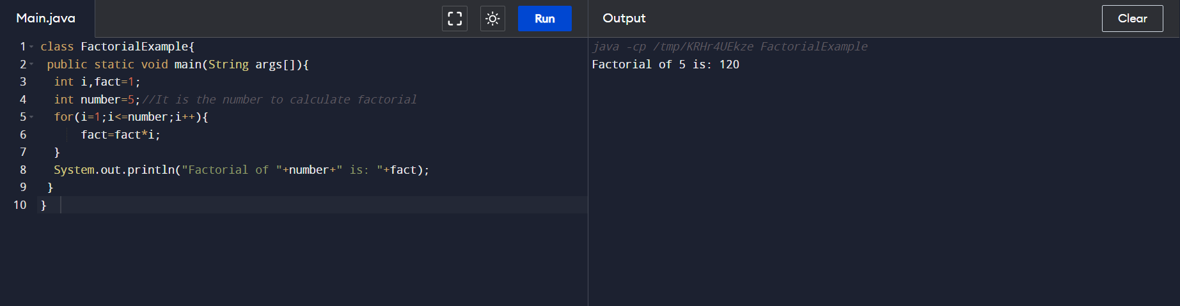

21. Write a program to print the following pattern

Code:-

// Java Program to print pattern

// Number-increasing pyramid

import java.util.*;

public class GeeksForGeeks {

// Function to demonstrate pattern

public static void printPattern(int n)

{

int i, j;

// outer loop to handle number of rows

for (i = 1; i <= n; i++) {

// inner loop to handle number of columns

for (j = 1; j <= i; j++) {

// printing column values upto the row

// value.

System.out.print(j + " ");

}

// print new line for each row

System.out.println();

}

}

// Driver Function

public static void main(String args[])

{

int n = 6;

printPattern(n);

}

}

OutPut :-

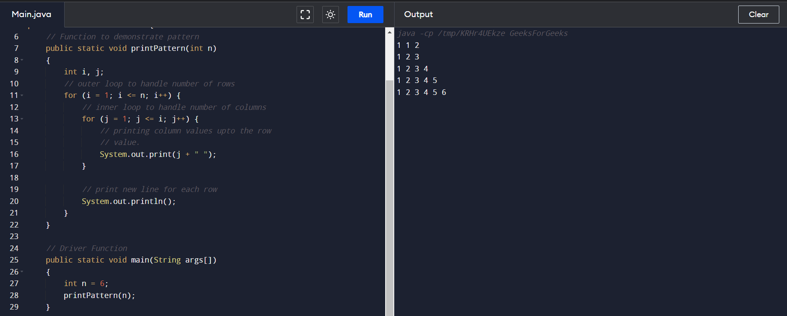

22. Find the year of the given date is leap year or not

Code :-

// Java program to find a leap year

// Importing Classes/Files

import java.io.*;

// Class for leap-year dealing

public class GeeksforGeeks {

// Method to check leap year

public static void isLeapYear(int year)

{

// flag to take a non-leap year by default

boolean is_leap_year = false;

// If year is divisible by 4

if (year % 4 == 0) {

is_leap_year = true;

// To identify whether it is a

// century year or not

if (year % 100 == 0) {

// Checking if year is divisible by 400

// therefore century leap year

if (year % 400 == 0)

is_leap_year = true;

else

is_leap_year = false;

}

}

// We land here when corresponding if fails

// If year is not divisible by 4

else

// Flag dealing- Non leap-year

is_leap_year = false;

if (!is_leap_year)

System.out.println(year + " : Non Leap-year");

else

System.out.println(year + " : Leap-year");

}

// Driver Code

public static void main(String[] args)

{

// Calling our function by

// passing century year not divisible by 400

isLeapYear(2000);

// Calling our function by

// passing Non-century year

isLeapYear(2002);

}

}

OutPut:-

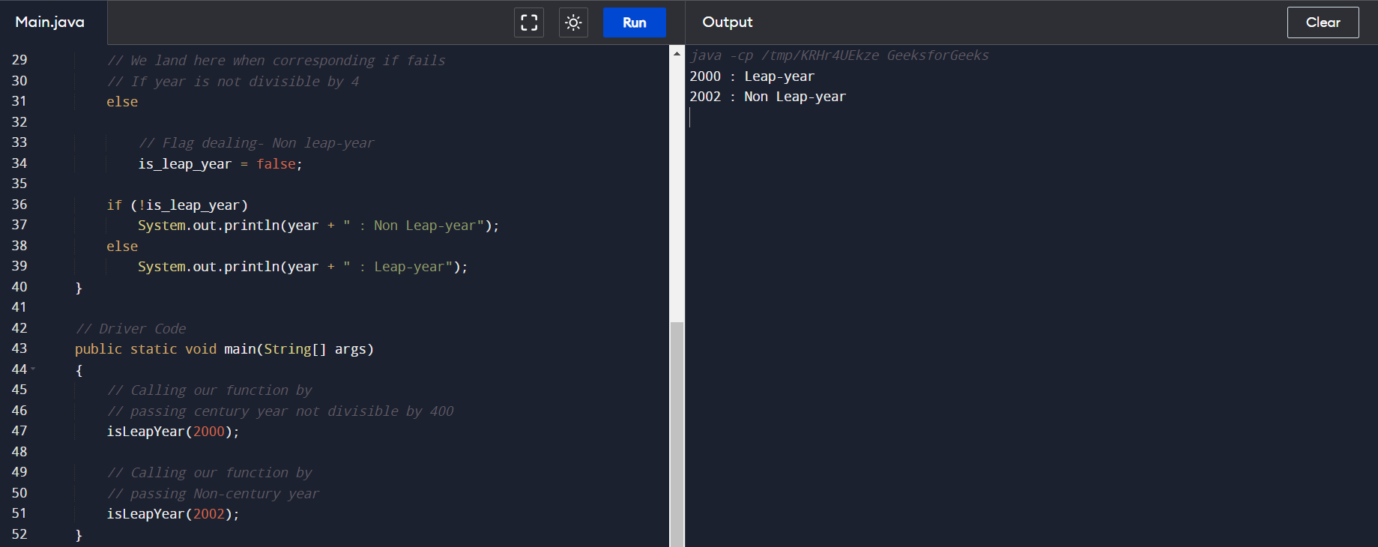

23. Find the number of factors for the given number

Code :-

public class Main {

public static void main(String[] args) {

// positive number

int number = 60;

System.out.print("Factors of " + number + " are: ");

// loop runs from 1 to 60

for (int i = 1; i <= number; ++i) {

// if number is divided by i

// i is the factor

if (number % i == 0) {

System.out.print(i + " ");

}

}

}

}

OutPut:-

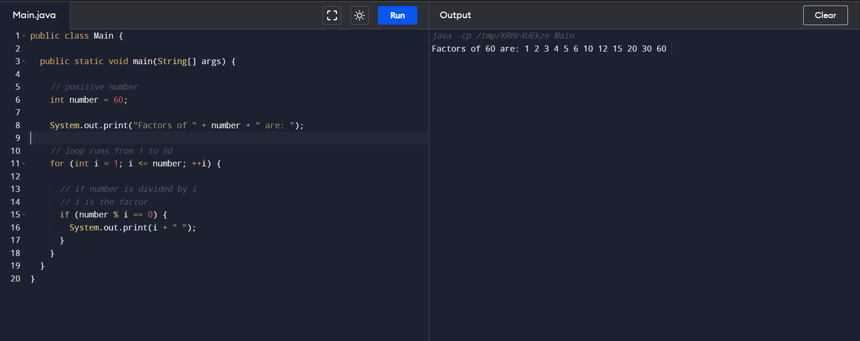

24. Write a program to print the given number is Perfect number or not?

Code:-

// Java program to check if a given

// number is perfect or not

class GFG {

// Returns true if n is perfect

static boolean isPerfect(int n)

{

// 1 is not a perfect number

if (n == 1)

return false;

// sum will store the sum of proper divisors

// As 1 is a proper divisor for all numbers

// initialised sum with 1

int sum = 1;

// Looping through the numbers to check if they are

// divisors or not

for (int i = 2; i < n; i++) {

if (n % i == 0) {

sum += i;

}

}

// If sum of divisors is equal to

// n, then n is a perfect number

if (sum == n)

return true;

return false;

}

public static void main(String[] args)

{

int n = 6;

if (isPerfect(n))

System.out.println(n + " is a perfect number");

else

System.out.println(

n + " is not a perfect number");

}

}

OutPut:-

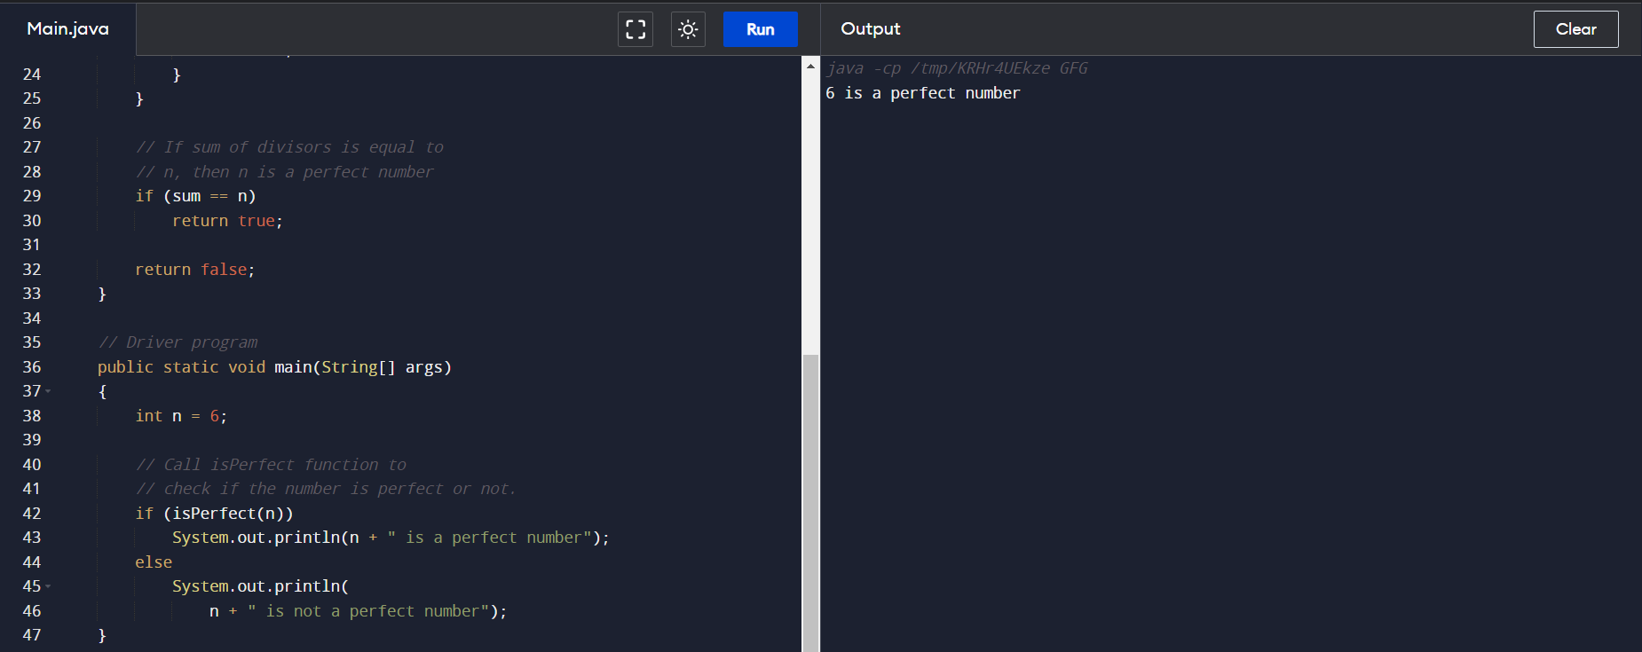

25. Write a program to print the number of vowels in the given statement?

Code:-

// Java Program to Count Number of Vowels

// in a String in a iterative way

import java.io.*;

public class vowel {

public static void main(String[] args)

throws IOException

{

String str = "GeeksForGeeks";

str = str.toLowerCase();

int count = 0;

for (int i = 0; i < str.length(); i++) {

// check if char[i] is vowel

if (str.charAt(i) == 'a' || str.charAt(i) == 'e'

|| str.charAt(i) == 'i'

|| str.charAt(i) == 'o'

|| str.charAt(i) == 'u') {

// count increments if there is vowel in

// char[i]

count++;

}

}

// display total count of vowels in string

System.out.println(

"Total no of vowels in string are: " + count);

}

}

OutPut :-

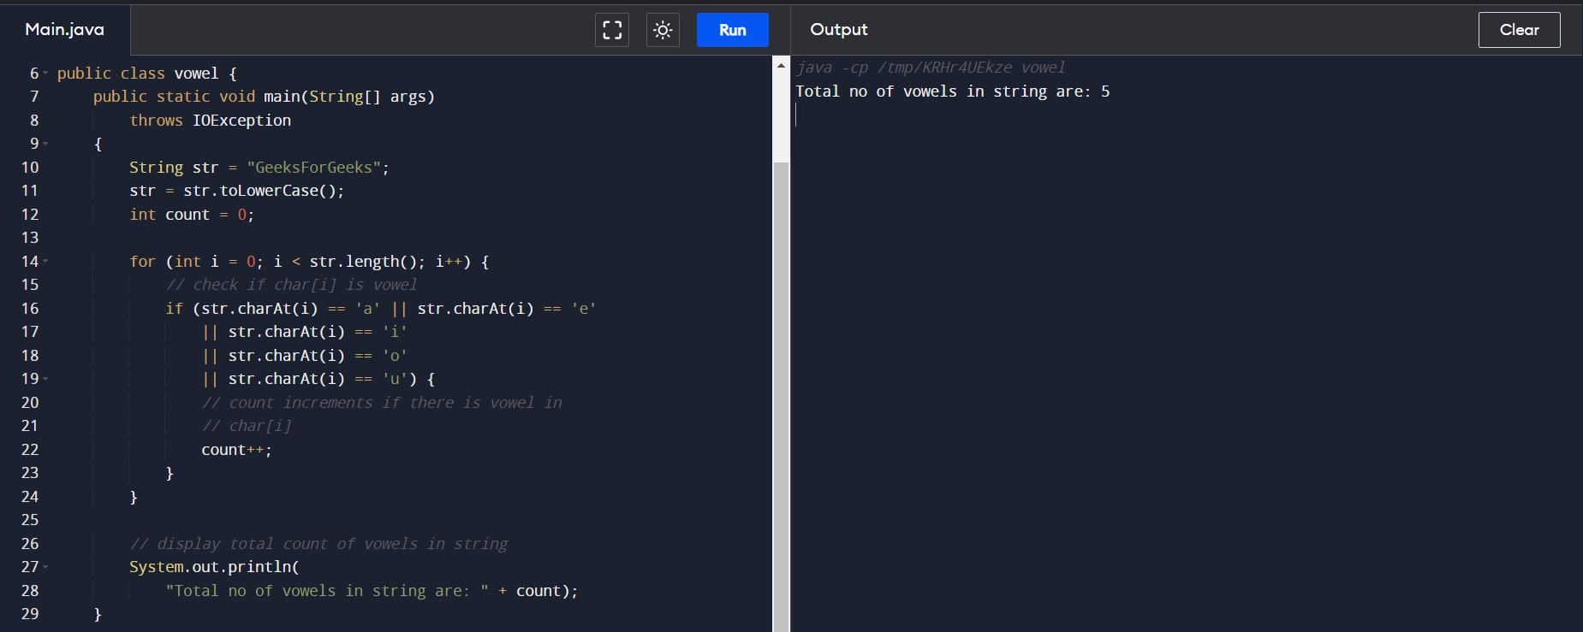

26. Write a program to print consonants and vowels separately in the given word

Code:-

**public** **class** CountVowelConsonant {

**public** **static** **void** main(String[] args) {

        //Counter variable to store the count of vowels and consonant

**int** vCount = 0, cCount = 0;

        //Declare a string

        String str = "This is a really simple sentence";

        //Converting entire string to lower case to reduce the comparisons

        str = str.toLowerCase();

**for**(**int** i = 0; i < str.length(); i++) {

            //Checks whether a character is a vowel

**if**(str.charAt(i) == 'a' || str.charAt(i) == 'e' || str.charAt(i) == 'i' || str.charAt(i) == 'o' || str.charAt(i) == 'u') {

                //Increments the vowel counter

                vCount++;

            }

            //Checks whether a character is a consonant

**else** **if**(str.charAt(i) >= 'a' && str.charAt(i)<='z') {

                //Increments the consonant counter

                cCount++;

            }

        }

        System.out.println("Number of vowels: " + vCount);

        System.out.println("Number of consonants: " + cCount);

    }

}

OutPut:-

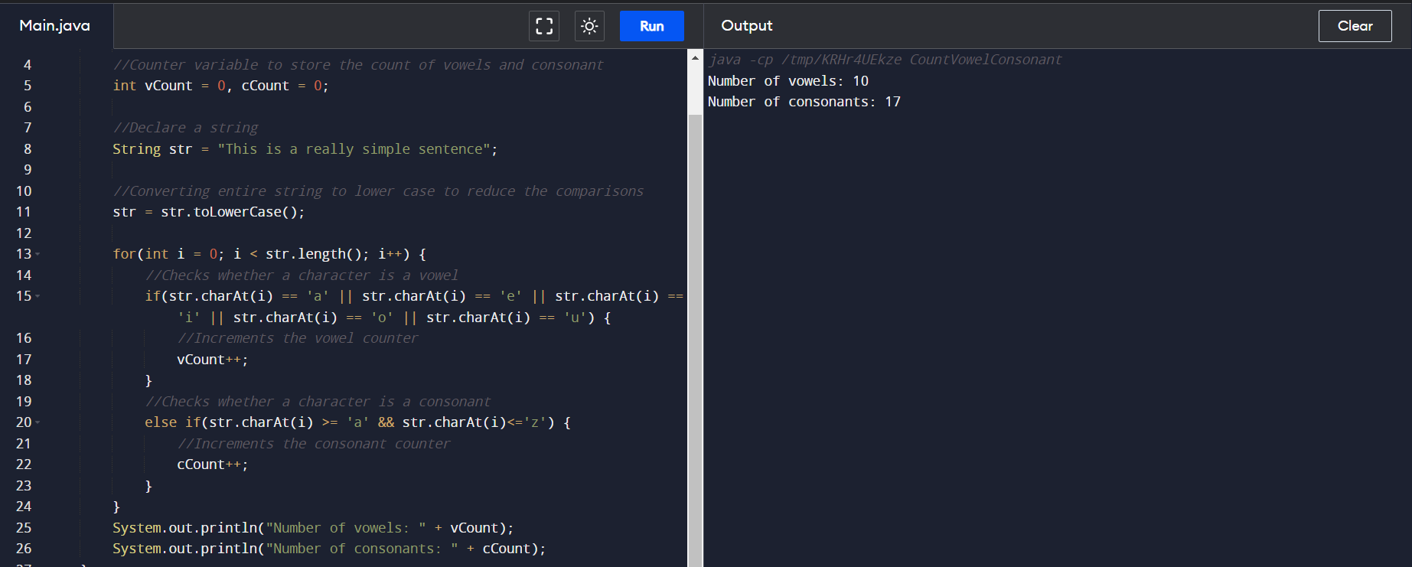

27. Write a program to print the Fibonacci series.

Code:-

// Java program for the above approach

class GFG {

// Function to print N Fibonacci Number

static void Fibonacci(int N)

{

int num1 = 0, num2 = 1;

int counter = 0;

// Iterate till counter is N

while (counter < N) {

// Print the number

System.out.print(num1 + " ");

// Swap

int num3 = num2 + num1;

num1 = num2;

num2 = num3;

counter = counter + 1;

}

}

// Driver Code

public static void main(String args[])

{

// Given Number N

int N = 10;

// Function Call

Fibonacci(N);

}

}

OutPut:-

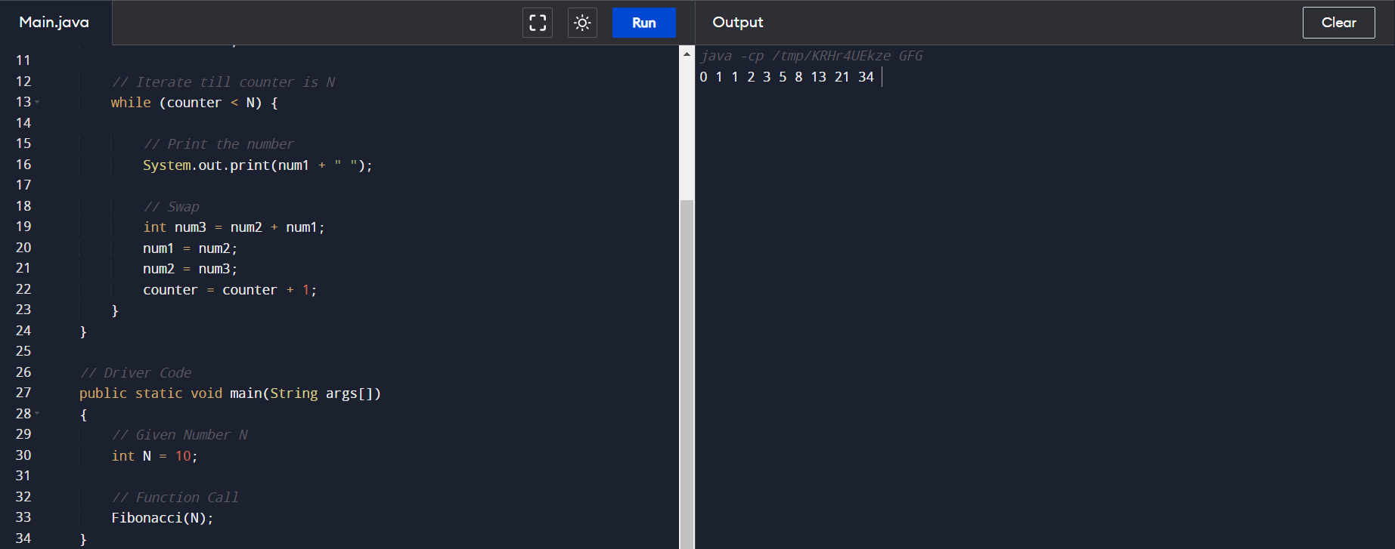

28. Write a program to find the square, cube of the given decimal number

Code:-

import java.util.Scanner;

import java.lang.*;

public class threenum {

public static void main(String args[]) {

int num, a, b, c;

Scanner sc = new Scanner(System.in);

System.out.print("Enter The Number :\n\n");

num = sc.nextInt();

a = num;

b = num * num;

c = num * num * num;

System.out.println("\nOutput Is = " + a + " ," + b + " ," + c + "\n\n");

}

}

OutPut:-

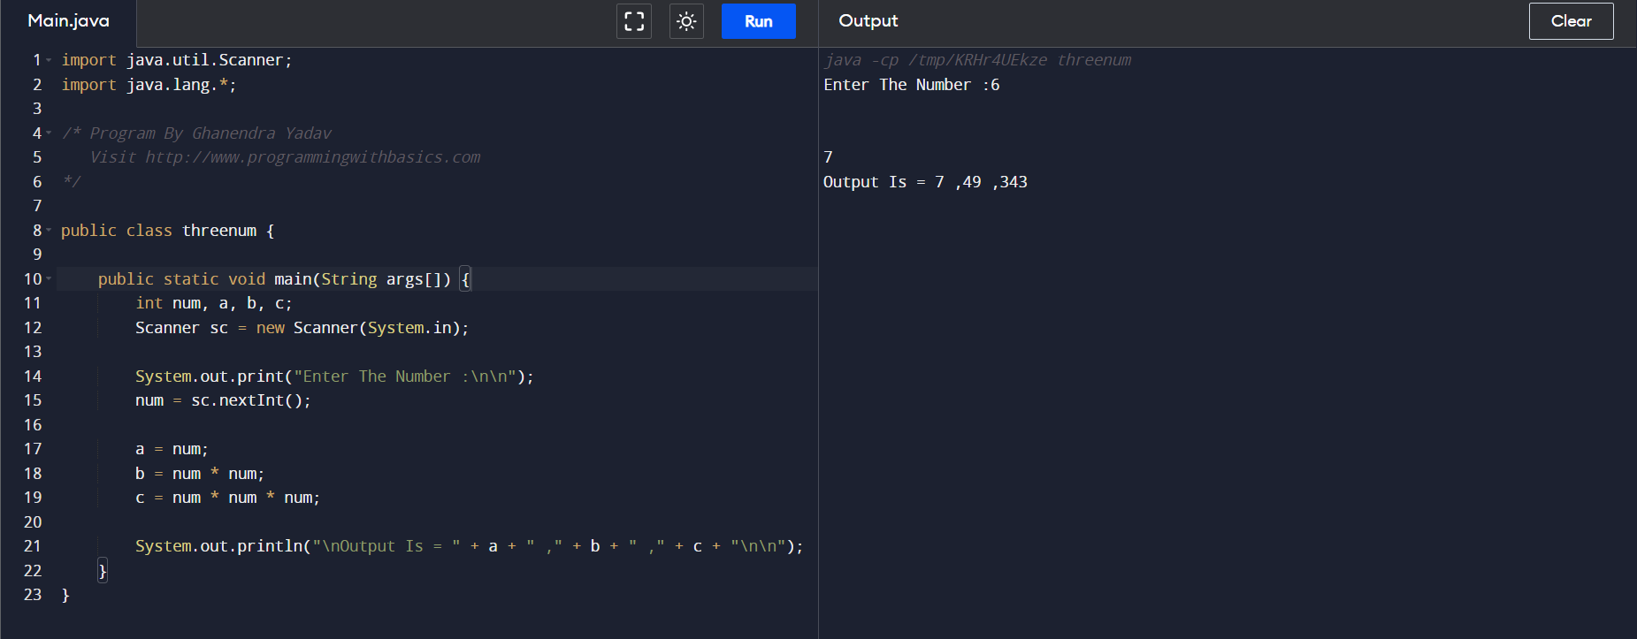

29. Program to find the frequency of each element in the array.

Code:-

**public** **class** Frequency {

**public** **static** **void** main(String[] args) {

        //Initialize array

**int** [] arr = **new** **int** [] {1, 2, 8, 3, 2, 2, 2, 5, 1};

        //Array fr will store frequencies of element

**int** [] fr = **new** **int** [arr.length];

**int** visited = -1;

**for**(**int** i = 0; i < arr.length; i++){

**int** count = 1;

**for**(**int** j = i+1; j < arr.length; j++){

**if**(arr[i] == arr[j]){

                    count++;

                    //To avoid counting same element again

                    fr[j] = visited;

                }

            }

**if**(fr[i] != visited)

                fr[i] = count;

        }

        //Displays the frequency of each element present in array

        System.out.println("---------------------------------------");

        System.out.println(" Element | Frequency");

        System.out.println("---------------------------------------");

**for**(**int** i = 0; i < fr.length; i++){

**if**(fr[i] != visited)

                System.out.println("    " + arr[i] + "    |    " + fr[i]);

        }

        System.out.println("----------------------------------------");

    }}

OutPut:-

